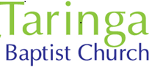

Mother’s Day

New words
Characteristics of mothers | What mothers do
kind | nourish
compassionate | protect
hard working | treasure
courageous | encourage
thoughtful | cherish

conversation starters
- When is Mother’s Day?
- How do you usually celebrate Mother’s Day?
- Is being a good mother easy? Why? / Why not?
- Which is more important: Mother’s Day or Father’s Day? Why?
- What are some good Mother’s Day gifts?
- Should Mother’s Day be a holiday? Why? / Why not?
- Can you remember what you did last Mother’s Day?
- Is it a good idea to give a Mother’s Day card to your mother?
- What are three good things about being a mother?

