Fruit

New words
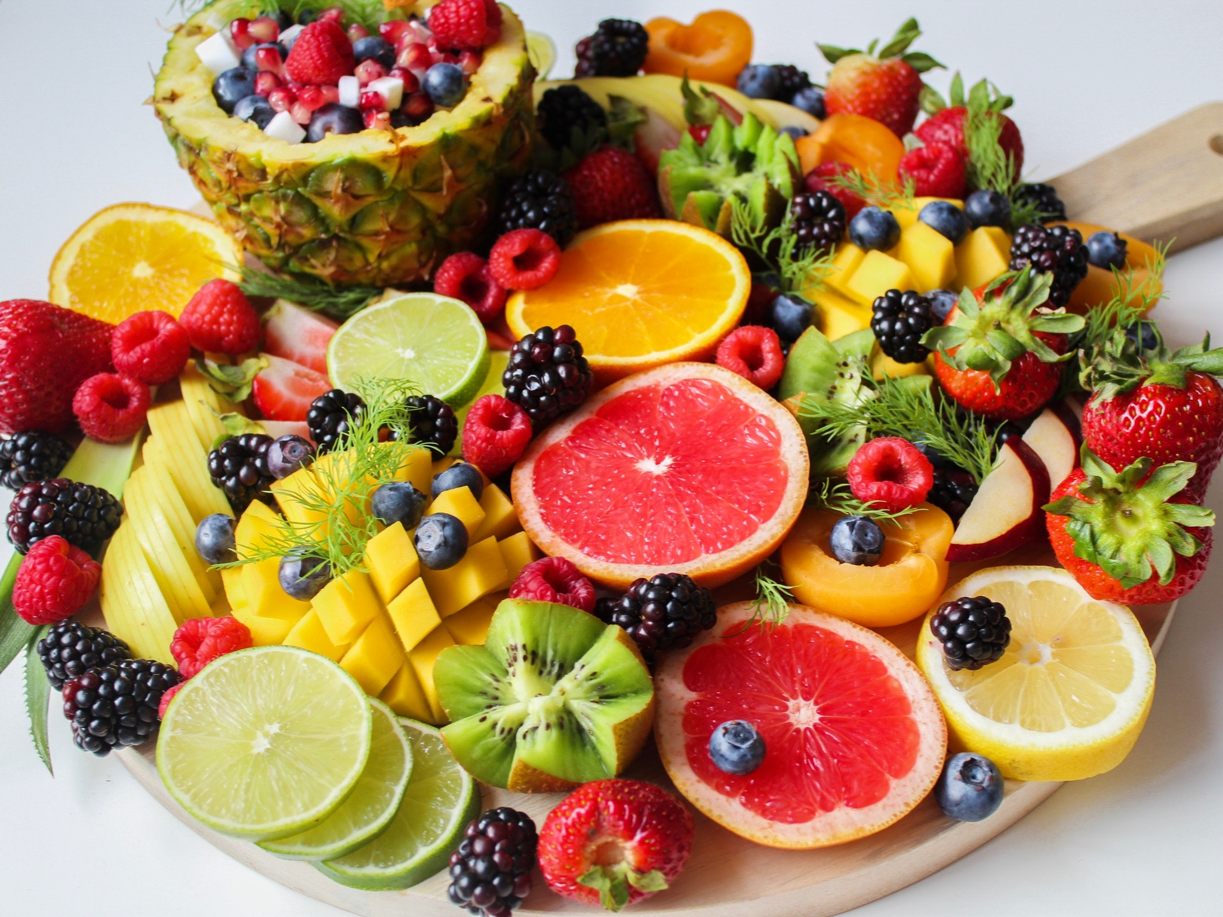
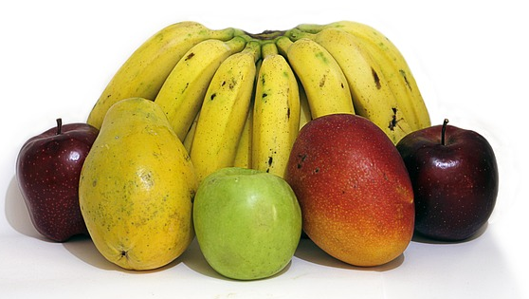
Which of these fruit can you name in English?

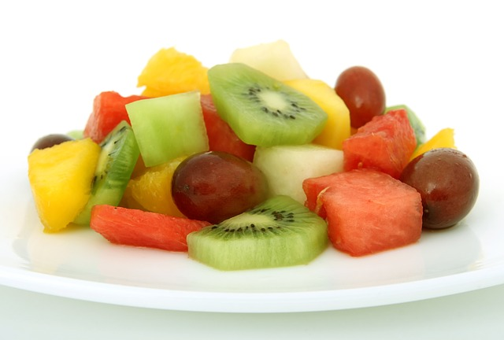

Can you find:
orange, mango, raspberries, blueberries, kiwi fruit, lime, strawberries, pineapple, mulberries, apricot, grapefruit, banana, apple, watermelon, grapes, honey dew
Which of these fruit are:
sweet, sour, crunchy, smooth, rough, seedy, juicy, hard,soft

conversation activities

Role play “At the green grocer’s”

Green grocer’s | Customer
Good morning | Good morning
How can I help you? | I would like 1 kg of pears, 1 kg of bananas and 1kg of oranges, please
Anything else? | No, thank you. How much are they?
They are $12.00 please | Thank you
Goodbye | Goodbye

